Mini Project Report – Applied System Development

./



Life Cycle and Software Testing

Multi-functional Electronics Calculator



### Document History

|  |  |  |  |  |  |
| --- | --- | --- | --- | --- | --- |
| **Ver. Rel.**  **No.** | **Release Date** | **Prepared. By** | **Reviewed By** | **To be approved By** | **Remarks/Revision Details** |
| 1 | 06/07/21 | 99004902 | 99004902 | Pagala Prithvi Shekar |  |
| 2 | 06/07/21 | 99004398 | 99004398 | Pagala Prithvi  Shekar |  |
| 3 | 06/07/21 | 99004900 | 99004900 | Pagala Prithvi Shekar |  |
| 4 | 06/07/21 | 99004904 | 99004904 | Pagala Prithvi Shekar |  |
| 5 | 06/07/21 | 99004903 | 99004903 | Pagala Prithvi Shekar |  |



**TABLE OF CONTENTS**

Document History 2

Introduction 6

Product Built: Multi-functional Electronics Calculator 6

SWOT Analysis 7

7

4W's and 1'H 8

Who 8

What 8

When 8

Where 8

How 8

Requirements 9

Research 9

Cable 9

Series Circuit Analysis 9

Source Transformation 9

Star (Y) and Delta (Δ) Conversion 9

Current Division 9

Voltage Division 10

Equivalent Resistance, Capacitance and Inductance of Circuits 10

Resistor color code 10

Circular Convolution using FFT 10

Defining the System 11

How to Run 11

Detailed Requirements 12

High Level Requirements 12

Low Level Requirements 12

Design 15

System Design 15

High Level Design 16

Low level Requirements Diagram 18

Test Plan 28

High Level Test Plan 28

Low Level Test Plan 29

Implementation Screenshots:- 35

Main Menu 35

Program Outputs 36

Basic Circuit Solver 36

Cable Calculation 36

37

Circuit Calculator 37

Convolution 39

Electronic Formula Calculation 39

Resistor Colour Coding 40

Badges 41

Build 41

Test 41

Static CPP 42

GCONV 44

Valgrind 46

Git Inspector…………………………………………………………………………………………………47



# Introduction

The project mainly aims in the making of a multifunctional electronic calculator which will be very useful to young and aspiring electrical and electronics engineers. As we know that the electrical and electronics background has some heavy circuit calculations, we have designed a calculator which will make your work easy. In this project the programming language used is C.

# Product Built: Multi-functional Electronics Calculator

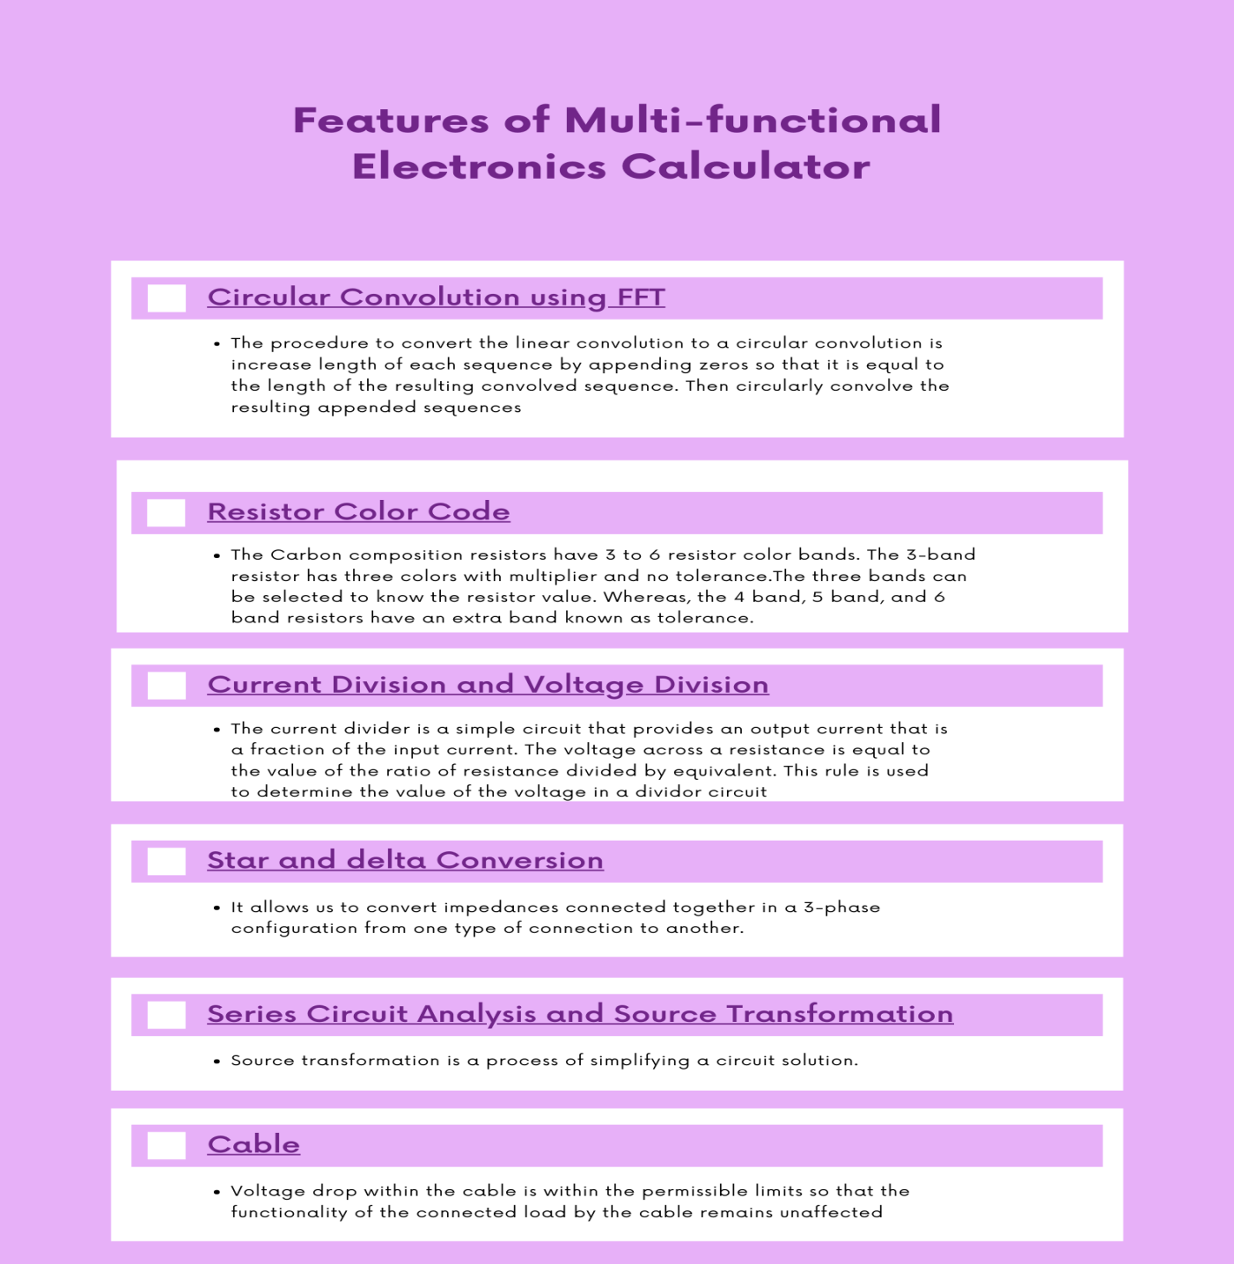

# SWOT Analysis

# 

# 4W's and 1'H

### Who

### 

### What

### 

### When

### Where

### How

* Students facing difficulty with implementation.
* Intended for people who want to calculate current and Voltage Division, Equivalent Resistance, resistor colour code, implementation of logic circuits and electrical and electronics parameters
* Using C programming to implement the numerical algorithms
* It provides you with quick calculation of electrical and electronics parameters
* When these electronic parameters are required in simple projects or lab work

* Users can use this application on their desktop or laptop terminal
* Thinking about how the computations involved in finding the calculations can be easily implemented programmatically.





# Requirements

### Research

**Need and Importance of Electronics formula Calculations**

The requirements of the project was to analyse and find out what is already available and what improvement can be made so that its useful to most to of the people.

## Cable

* The conductor cross-section shall be chosen such that the conductor withstands prospective short circuit current for a specified duration of time.
* Area of cross-section of the conductor shall be sized to carry estimated load current continuously such that the temperature rise of the conductor is within the acceptable limits for the installation conditions foreseen
* Voltage drop within the cable is within the permissible limits so that the functionality of the connected load by the cable remains unaffected

## Series Circuit Analysis

* A Circuit is a collection of interconnected components.
* We assume components to be linear in nature.
* We will analyze Series circuit , based on input provided by user
* We will be mainly focusing on Calculating Equivalent Impedance, Power factor etc.

## Source Transformation

* Source transformation is a process of simplifying a circuit solution.
* Here we transform voltage source in to current source and vice-versa.
* Performing a source transformation consists of using Ohm's law.

## Star (Y) and Delta (Δ) Conversion

* Star and Delta connections are the two types of connections in 3-phase circuits.
* The transformation is used to establish equivalence for networks with three terminals.
* Where three elements terminate at a common node and none are sources, the node is eliminated by transforming the impedances.
* It allows us to convert impedances connected together in a 3-phase configuration from one type of connection to another.

## Current Division

* The current divider is a simple circuit that provides an output current that is a fraction of the input current
* Current division is the splitting of current between branches of the divider
* We use the current division rule to find the current in the branches

## Voltage Division

* The voltage across a resistance is equal to the value of the ratio of resistance divided by equivalent
* This rule is used to determine the value of the voltage in a divider circuit

## Equivalent Resistance, Capacitance and Inductance of Circuits

* The equivalent resistance, capacitance and inductance of a circuit can be calculated by their equivalent formulas
* Passive components in parallel and series circuits add up in ratios relating to their properties

## Resistor color code

* The resistor colour code was developed during the year 1920. The colour bands are printed on the body of tiny resistor components. Generally, for colour code, we can use this resistor mnemonic called BBROY. This color-coding shortcut has an acronym for how to identify a resistor value.
* The Carbon composition resistors have 3 to 6 resistor colour bands. The 3-band resistor has three colours with multiplier and no tolerance. The three bands can be selected to know the resistor value. Whereas, the 4 band, 5 band, and 6 band resistors have an extra band known as tolerance.

## Circular Convolution using FFT

* Normal convolution between two signals can be described as sliding and multiplication of one of the signals reversed against the other signal.
* FFT is a fast algorithm for execution of DFT. The multiplication of two DFTs is equivalently a circular convolution of the two sequences.
* We can make use of DFT for computation of convolution as the circular convolution in time domain is equivalently a multiplication in the DFT domain using a property of convolution.
* We need to convert the linear convolution to a circular convolution and then make use of FFT algorithm to reduce the number of computation for filtering.
* The procedure to convert the linear convolution to a circular convolution is increase length of each sequence by appending zeros so that it is equal to the length of the resulting convolved sequence. Then circularly convolve the resulting appended sequences

**Implementation with Programming Language C**

* + C defines datatypes like double which have high precision and can be used to implement the algorithms with high accuracy.
  + The loops and precision can be used to iterate the algorithms in an efficient manner.



**Cost and Features**

* The advantage of this project the quickness in which the program works and no need to perform heavy calculation which will be taken care by the program
* A lot of time and money can be saved in this project as the result leads to quick installation and accurate results.

### Defining the System

The system will be getting some essential parameters from the user and it will compute the values and with which it will be able to choose or design the product.

## How to Run

# For Building the main application

make all

# For Running the main application

make run

# For Building the test file

make test



# Detailed Requirements

## High Level Requirements

|  |  |  |  |
| --- | --- | --- | --- |
| **ID** | **Description** | **Category** | **Status** |
| HA01 | Basic Circuit Solver | Technical | Implemented |
| HA02 | Cable Capacities | Technical | Implemented |
| HA03 | Voltage and Current Calculations | Technical | Implemented |
| HA04 | Passive Circuit Components Calculations | Technical | Implemented |
| HA05 | Calculating resistance based on color code | Technical | Implemented |
| HA06 | Calculating Circular Convolution | Technical | Implemented |
| HA07 | Calculation of Electronic formula | Technical | Implemented |

# Low Level Requirements

|  |  |  |  |
| --- | --- | --- | --- |
| **ID** | **Description** | **HLR ID** | **Status** |
| LA01 | Finding Equivalent Impedance in Series RLC Circuit | HA01 | Implemented |



|  |  |  |  |
| --- | --- | --- | --- |
| LA02 | Finding Power Factor in Series RLC Circuit | HA01 | Implemented |
| LA03 | Star Delta Conversion | HA01 | Implemented |
| LA04 | Source Transformation | HA01 | Implemented |
| LA05 | Current Divsion Calculation | HA03 | Implemented |
| LA06 | Voltage Divsion Calculation | HA03 | Implemented |
| LA07 | Equivalent Parallel R,L,C | HA04 | Implemented |
| LA08 | Equivalent Series R,L,C | HA04 | Implemented |
| LA09 | Calculating Ampacity | HA02 | Implemented |
| LA10 | Calculating Voltage Drop | HA02 | Implemented |
| LA11 | Calculating Derating Factors | HA02 | Implemented |
| LA12 | Calculation of Rasistance from the rasistor color band | HA05 | Implemented |
| LA13 | Calculating Current,Voltage,Rasistance,and other electronic formulas | HA05 | Implemented |



|  |  |  |  |
| --- | --- | --- | --- |
| LA14 | Inputting 2 discrete time signals | HA06 | Implemented |
| LA15 | FFT Calculation for Input time signal as 4 | HA06 | Implemented |
| LA16 | FFT Calculation for Input time signal as 8 | HA06 | Implemented |



# Design

## System Design

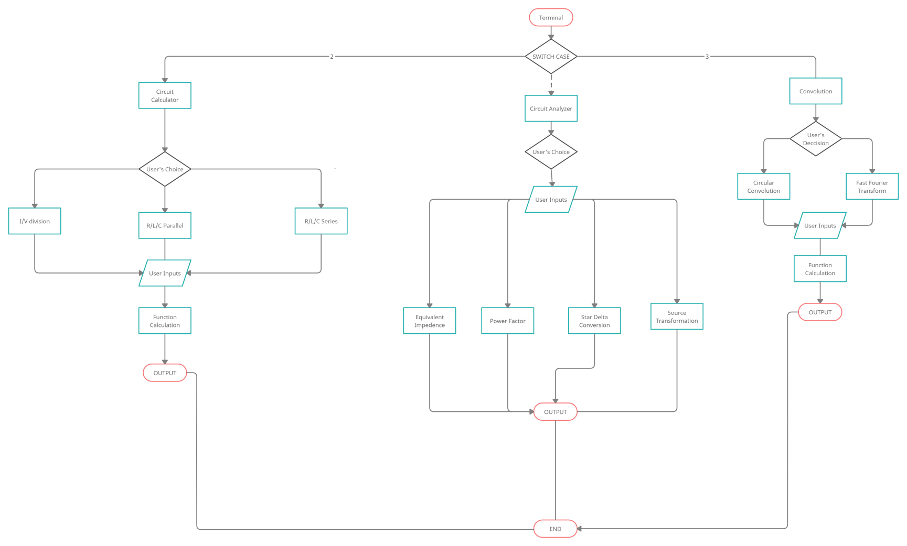



High level Requirements

**Architecture**

## High Level Design

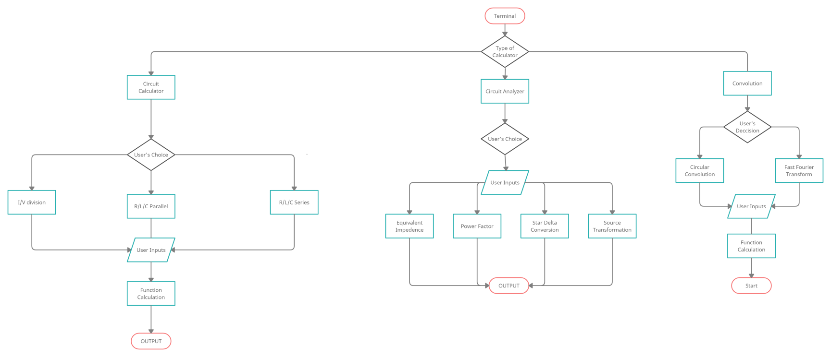

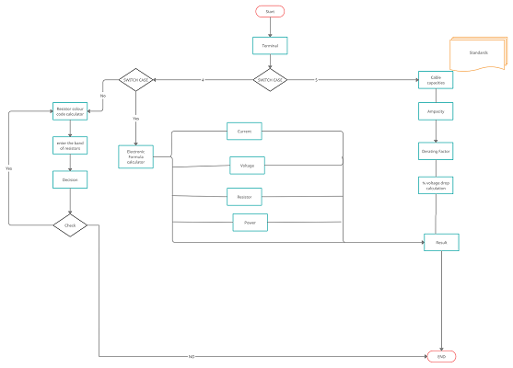



## Low level Requirements Diagram

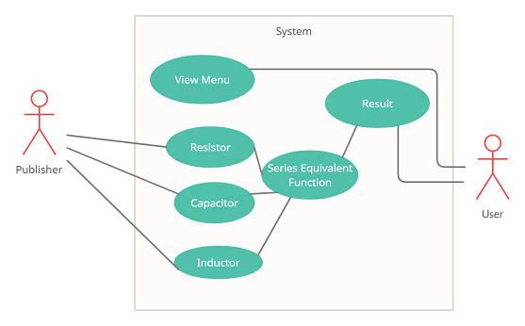

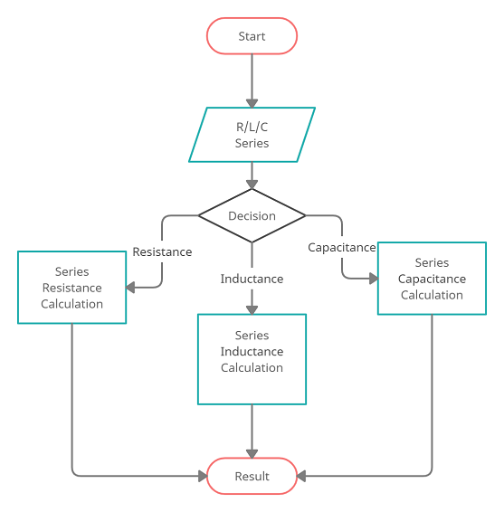

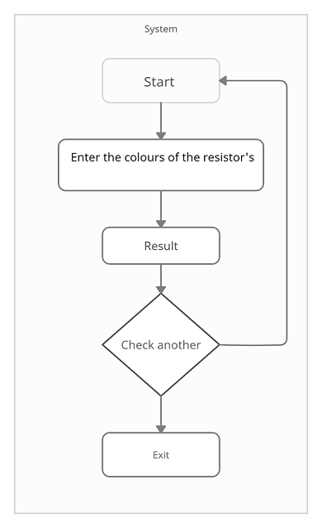

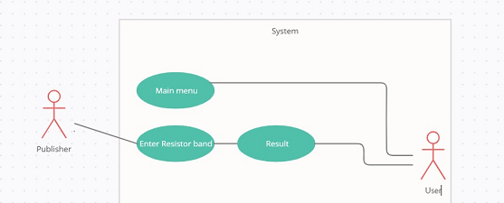

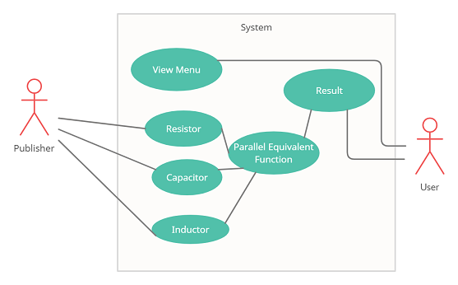

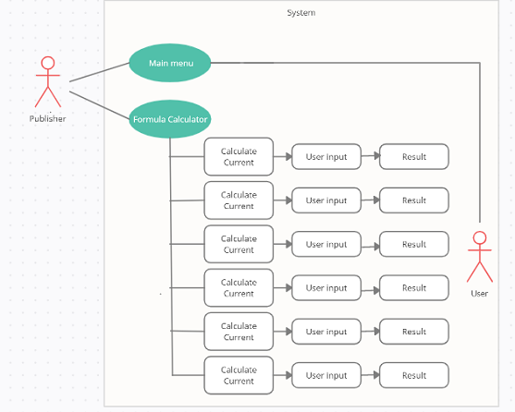

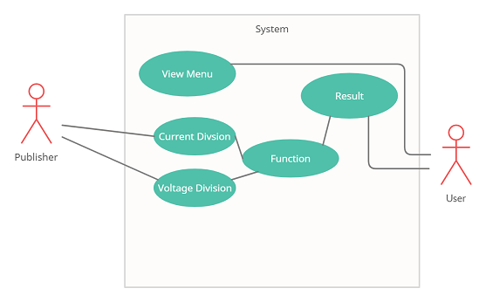

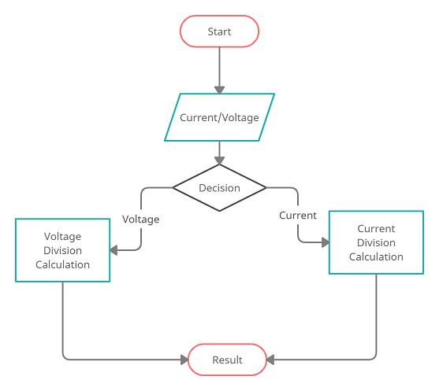



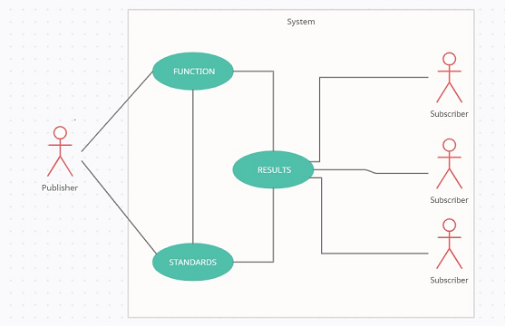

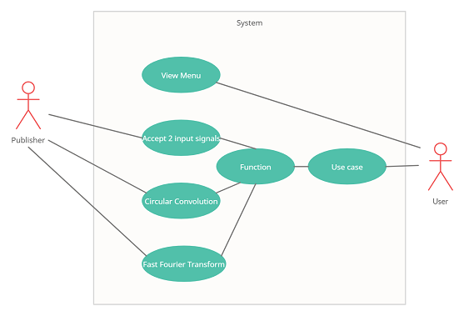





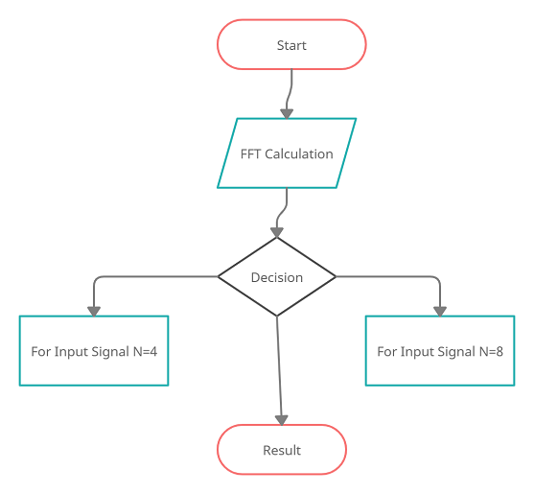

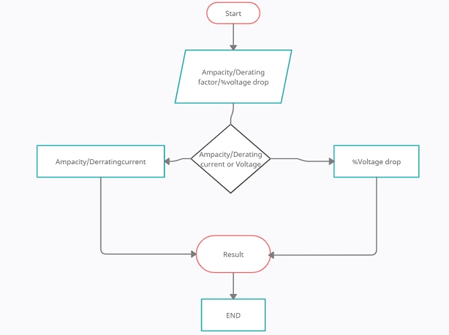

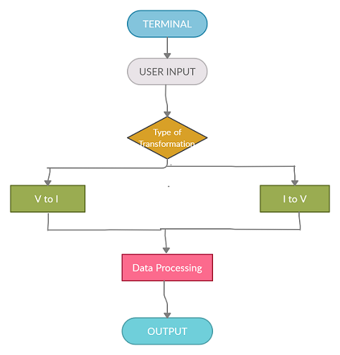

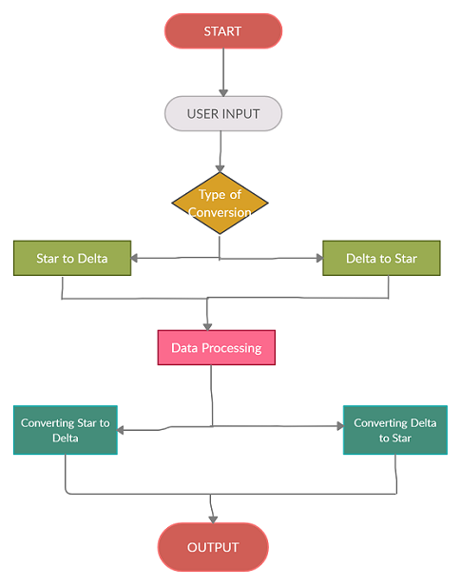





# Test Plan

## High Level Test Plan

|  |  |  |  |  |  |
| --- | --- | --- | --- | --- | --- |
| **Test ID** | **Description** | **Exp I/P** | **Exp O/P** | **Actual O/P** | **Type Of**  **Test** |
| H_01 | Basic circuit solver | - | - | - | Technical |
| H_02 | Cable Capacities | - | - | - | Technical |
| H_03 | Circuit Calculator | - | - | - | Technical |
| H_04 | Circular Convolution | - | - | - | Technical |



## Low Level Test Plan

|  |  |  |  |  |  |
| --- | --- | --- | --- | --- | --- |
| **Test ID** | **Description** | **Exp I/P** | **Exp O/P** | **Actual O/P** | **Type Of**  **Test** |
| L_01 | Finding Equivalent Impedance in Series RLC Circuit | User input->Value of R,L,C,w | 2.740646 | 2.740646 | Scenario/T echnical |
| L_02 | Finding Power Factor in Series RLC Circuit | User input->Value of R,L,C,w a given function | 2.706543 | 2.706543 | Scenario/T echnical |
| L_03 | Star Delta Conversion | User input->Corresponding values of R,L,C to a given function | 0.517727 | 0.517727 | Scenario/T echnical |
| L_4 | Source Transformation | User input-> Values of Resistance and sources |  |  |  |



|  |  |  |  |  |  |
| --- | --- | --- | --- | --- | --- |
| L_9 | Ampacity calculation | User input-> Values system voltage=0.415 and transformer rating=200 | 143.760208 | SUCCESS | Requirement |
| L_9 | Ampacity calculation | User input-> Values system voltage=2 and transformer rating=13 | 450.033321 | SUCCESS | Requirement |
| L_10 | Voltage drop calculation | User input-> Ampacity=143.7,systemvoltage=0.415,pf=0.8,Length=100,resistance=1.035,reactance=5.233 | 23796 | SUCCESS | Requirement |
| L_10 | Voltage drop calculation | User input-> Ampacity=120,systemvoltage=1,pf=1,Length=25,resistance=13,reactance=0.03 | 6754 | SUCCESS | Requirement |



|  |  |  |  |  |  |
| --- | --- | --- | --- | --- | --- |
| L_11 | Derating temperature calculation | User input-> Values site temperature=12 | 1.120000 | SUCCESS | Requirement |
| L_11 | Derating temperature calculation | User input-> Values site temperature=20 | 1.040000 | SUCCESS | Requirement |
| L_11 | Derating temperature calculation | User input-> Values site temperature=27 | 0.960000 | SUCCESS | Requirement |
| L_11 | Derating temperature calculation | User input-> Values site temperature=37 | 0.910000 | SUCCESS | Requirement |
| L_11 | Derating temperature calculation | User input-> Values site temperature=47 | 0.820000 | SUCCESS | Requirement |
| L_11 | derating depth calculation | User input-> Values site_depth=99 and rating=15 | 0.990000 | SUCCESS | Requirement |
| L_11 | derating depth calculation | User input-> Values site_depth=99 and rating=120 | 0.980000 | SUCCESS | Requirement |
| L_11 | derating depth calculation | User input-> Values site_depth=99 and rating=470 | 0.970000 | SUCCESS | Requirement |
| L_11 | derating depth calculation | User input-> Values site_depth=108 and rating=15 | 0.980000 | SUCCESS | Requirement |
| L_11 | derating depth calculation | User input-> Values site_depth=108 and rating=120 | 0.970000 | SUCCESS | Requirement |
| L_11 | derating depth calculation | User input-> Values site_depth=108 and rating=470 | 0.960000 | SUCCESS | Requirement |
| L_11 | derating depth calculation | User input-> Values site_depth=190 and rating=15 | 0.950000 | SUCCESS | Requirement |
| L_11 | derating depth calculation | User input-> Values site_depth=190 and rating=120 | 0.930000 | SUCCESS | Requirement |
| L_11 | derating depth calculation | User input-> Values site_depth=190 and rating=470 | 0.910000 | SUCCESS | Requirement |
| L_08 | Finding Equivalent Resistance in Series RLC Circuit | User input-> Values R1,R2,R3=10,10,10 | 30.000000 | SUCCESS | Requirement |



|  |  |  |  |  |  |
| --- | --- | --- | --- | --- | --- |
| L_08 | Finding Equivalent Capacitance in Series RLC Circuit | User input->Values C1,C2,C3=10,10,10 | 3.333333 | SUCCESS | Requirement |
| L_08 | Finding Equivalent Inductance in Series RLC Circuit | User input->Values L1,L2,L3=10,10,10 | 30.000000 | SUCCESS | Requirement |
| L_07 | Finding Equivalent Inductance in Parallel RLC Circuit | User input-> Values L1,L2,L3=10,10,10 | 3.000000 | SUCCESS | Requirement |
| L_07 | Finding Equivalent Capacitance in Parallel RLC Circuit | User input-> Values C1,C2,C3=10,10,10 | 30.333333 | SUCCESS | Requirement |
| L_07 | Finding Equivalent Resistance in Parallel RLC Circuit | User input-> Values R1,R2,R3=10,10,10 | 3.333333 | SUCCESS | Requirement |



|  |  |  |  |  |  |
| --- | --- | --- | --- | --- | --- |
| L_06 | Finding Voltage from Voltage Division Circuit | User input->Value of Vin=10,R1=20,R2=30 | 4.000000 | SUCCESS | Requirement |
| L_05 | Finding Current from Current Division Circuit | User input->Value of R1=30,R2=40,Iin=20 | I1=11.428571,I2=8.571429 | SUCCESS | Requirement |
| L_12 | Resistor color coding | User input-> Band1 - green ,Band2 - Black ,Band3 - yellow | 500k ohms | SUCCESS | Requirement |
| L_12 | Resistor color coding | User input-> Band1 - red ,Band2 - red ,Band3 - red | 220k ohms | SUCCESS | Requirement |
| L_13 | Electronic formula calculator | User input->Corresponding values of R,L,C | - | SUCCESS | Requirement |



# Implementation Screenshots:-

## Main Menu

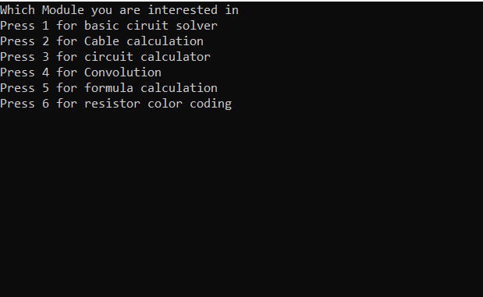



# Program Outputs

## Basic Circuit Solver

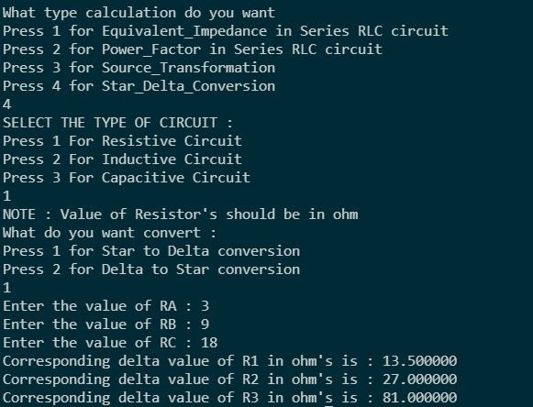

|  |  |
| --- | --- |
| Cable Calculationhttps://lh6.googleusercontent.com/3cG12iszfQG6oEiEmTJWLUFWZamx0itB826cdxUaa901f9hZAWfr1h2ddI5JmU1BxFsX_K3iRlKFSmAMVCnWUDa-rLBDLowwAP73QMwrGT-Ja3WIFiJeAYNbMcq44rxQflFIZvtjCircuit Calculator https://lh3.googleusercontent.com/ITKoepDVmLXFvJixmdaTG-uEsUSYbLFdRCPQ-epeklNF2qjJXVkcaZHejO5Wxva4EEcryjwEtc7P5N_jiEKTuZ8lIPVbLeSw1jKr_dIXVYn635gCw7294sK8wj519uVJtGryx2Mi  **https://lh3.googleusercontent.com/OS_02hx_NG7v_um1nyJ_gbWpr21US_M3BbPFa3iFzM60lyRfnpEO6iAangpq8MeyxWeeO584yfRDPqA-WF6xqacNgbs6mq3f-iJE052TFpIkskXP2-JJEHO1EvM8J4oamBtE3DH2**  **https://lh5.googleusercontent.com/UpYkWsgZ2okHo41qdzA0KKGfarHDCVqNEVg2YH-D8-jeS-SWmwOPzIZU6i5dQzQ-Z5wJEhVRyjJsRxDFVMuMN-zmQin5L30mRCMKQ-YoMNBewQb4sNEdwfQ_YssUE-26L4K2jCps** Convolution  Electronic Formula Calculation https://lh3.googleusercontent.com/RSHzXvpstSCE_G6losGAkySa-cHi-RT-CLf6a4eaqpPmOKgg1e6mdCW2gP97JQlVBw6vEflESUEcxJW6jPggN2pFrZA81ANydpFU2WFD5fylNcZeWAONaHNH631cKmjzgoRCfaT0  https://lh4.googleusercontent.com/MOFLQaN9Dcu1Is8ecHAT9bz-mwAp_7vmSz13ncGGnnyQHIcUFZhNjkpP9t6jOoMeYYOoHDjrlEUSS-01lNJ9mjIpUMmkZtPY5Ix5zsA_54jfe4M0dFvnZr40lmRbmPnONpEZHUxc https://lh6.googleusercontent.com/aquKGo41sTFMlULJzPoOxLe5q8lqRD3xPpQZPAQm-pjCT7LUPEhzUXTWO7-1aNXfpCKzAl5VZkc-5gXycxNyrSa_WzrPXX2rl53-d1WfA4Ikv6Hf01tlKRwxJk8lJWPQvkLyrYin https://lh4.googleusercontent.com/xI5k0OpXOeQd1r6SJv274-gXn4hHWdgoSN4LyQZ_IC_dn35bs30S02JIfJPPqa0E6OIcUCAJkuVCD184tkVLNEAb17NN2t5TpMLdm9mmxaelNHNVbMMaKrMpK1YzyfBJ2TAdeMkg https://lh4.googleusercontent.com/3M5eU791GnL8u61uZaMhEJnUpqHh4gDHHGEigHLt7ab1w7jFo_yxJchtHm8neyvT9BREY5VsQwor4dsPq4yQSwxKfIf-29LTNZULXCgAGxKDartzwWzvZ1hdO2WSx8vJdym3hi0V Resistor Colour Coding **https://lh3.googleusercontent.com/qhZDxiwNB1hmy4ZvzadvWUH-pu_sInxWK0R4XEMxJkc86xMCB3Mecj8NOidBc794cS9xr8oR2mBMFkJ86fN9YU8J6psV3n3QNTNUt2S12lXrPnPAx-QAyHK_1wu3i6LGM3M5zVsk**     BadgesBuild |  |

## Test

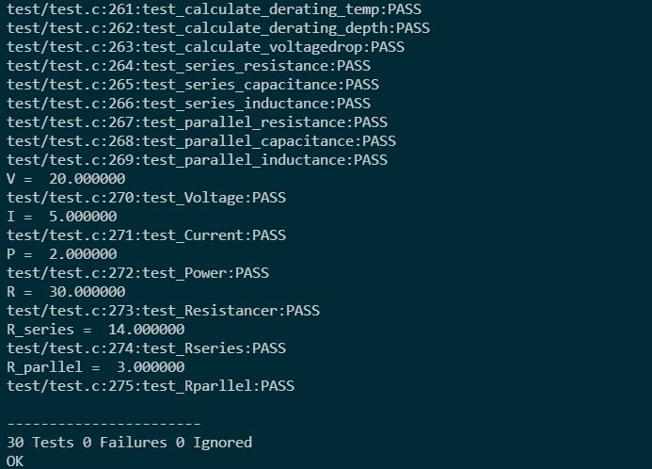

## Static CPP

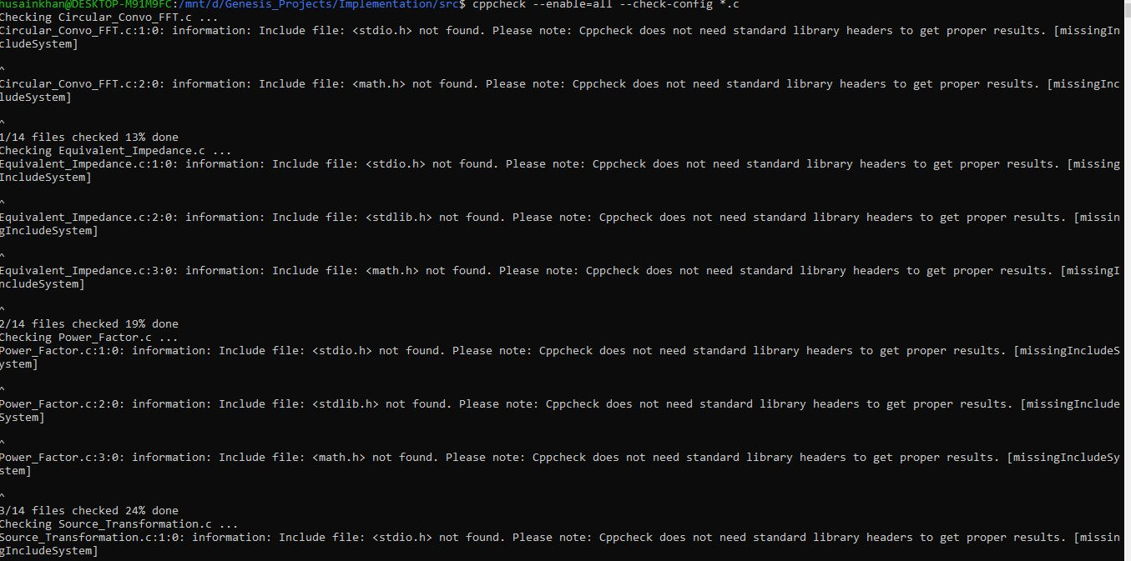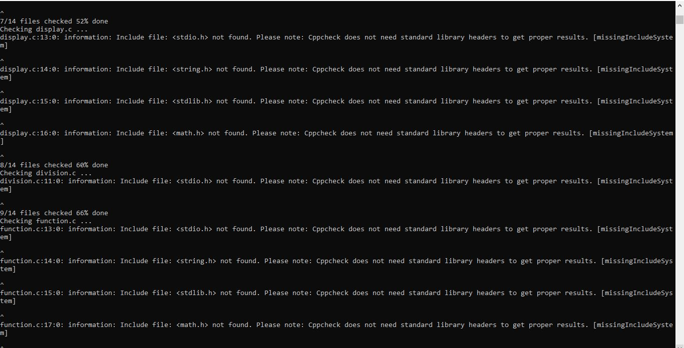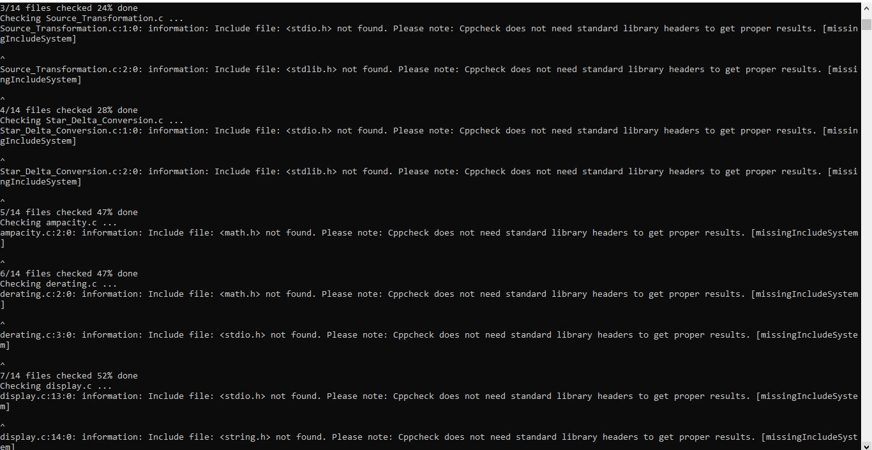

## GCONV

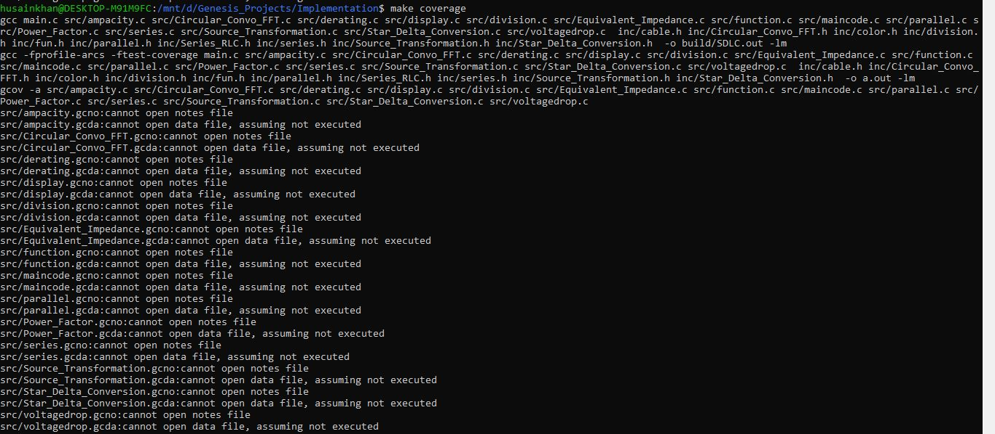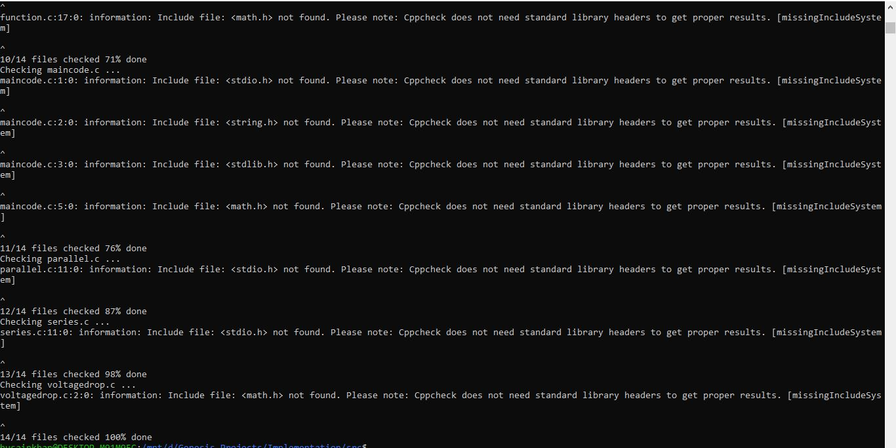

## Valgrind

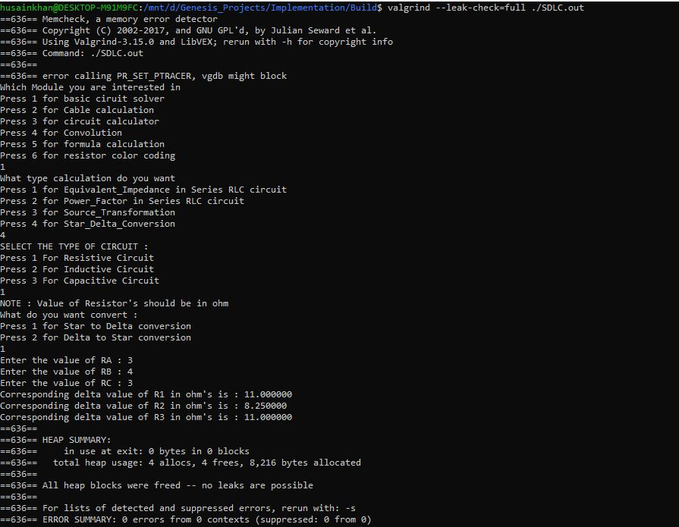





## Git Inspector

